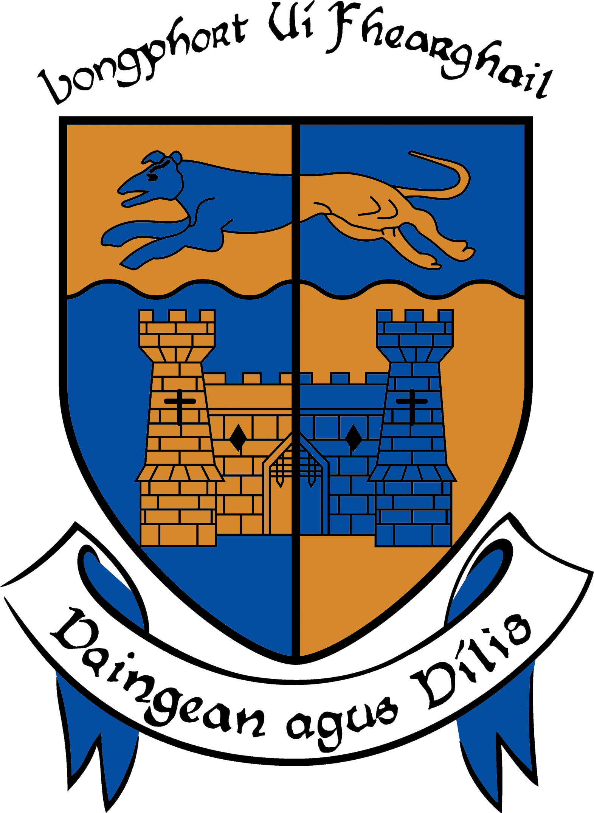

LONGFORD COUNTY COUNCIL

COMHAIRLE CHONTAE LONGFOIRT

Minutes of January Monthly Meeting of Longford County Council
held in the Council Chamber, Aras an Chontae, Longford on
Wednesday, 15th January 2014 at 4.00 p.m.

PRESIDING: Councillor Larry Bannon, Mayor.

MEMBERS PRESENT: Councillors – Gearoid O Bradaigh, John Browne,
Mick Cahill, Micheál Carrigy, Mark Casey,
Paul Connell, John Duffy, Sean Farrell Frank Kilbride, Donncha Mac Gleannáin, Victor Kiernan, Padraig Loughrey, Luie McEntire, Martin Mulleady, Colm Murray, Peggy Nolan, P.J Reilly, Mae Sexton, Barney Steele and Thomas Victory.

IN ATTENDANCE: Mr. Tim Caffrey, County Manager.
Mr. Jack Kilgallen, Director of Services.
Mr. Barry Lynch, Head of Finance/Director of Services.
Mr. Frank Sheridan, Director of Services.

MEETINGS
ADMINISTRATOR: Ms. Anne Lee.

Vote of Sympathy.

Mayor L. Bannon proposed and Councillor P. Nolan seconded that a vote of sympathy be extended to Councillor James Keogh and the Keogh family on the recent death of their Mother, May.

Vote of Congratulations.

The members congratulated Councillor Martin Mulleady and his wife, Patricia, on the recent birth of their baby son, Joe.

ADOPTION OF MINUTES.

On the proposal of Councillor M. Sexton seconded by Councillor M. Mulleady, the Minutes of Special Meeting held on the 11th December 2013 were confirmed and adopted.

On the proposal of Councillor M. Mulleady seconded by Councillor M. Sexton, the Minutes of Finance Committee Meeting held on the 11th December 2013 were confirmed and adopted.

On the proposal of Councillor F. Kilbride seconded by Councillor M. Mulleady, the Minutes of Adjourned Finance Committee Meeting held on the 16th December 2013 were confirmed and adopted.

On the proposal of Councillor M. Mulleady seconded by Councillor T. Victory, the Minutes of Monthly Meeting held on the 18th December 2013 were confirmed and adopted.

MATTERS ARISING FROM MINUTES.

None.

Suspension of Standing Orders.

Councillor M. Mulleady proposed and Councillor M. Casey seconded that Standing Orders be suspended to allow the members discuss the contents of letter dated 31st December 2013 received from the Department of the Environment, Community and Local Government regarding the review of the Housing Adaptation Grant Schemes for Older People and People with a Disability.

Housing Adaptation Grant Schemes for Older People and People with a Disability.

- Mobility Aids Housing Grant Scheme
- Housing Adaptation Grant for People with a Disability
- Housing Aid for Older People

The following documents, which had been circulated, were discussed in detail -

- Letter dated 31st December 2013 (received by the Director of Services on the
7th January 2014) from the Department of the Environment, Community and Local Government regarding Review of the Housing Adaptation Grant Schemes for Older People and People with a Disability.
- Report prepared by the Housing Section outlining the changes to the above schemes from the 1st January 2014.

The members expressed concern regarding changes to the schemes and agreed that
Ms. Jan O’Sullivan, Minister of State, Department of Environment, Community and Local Government with special responsibility for Housing and Planning be requested to receive a deputation from Longford County Council regarding the issue -
It was agreed that the following Councillors attend the proposed meeting, on behalf of Longford County Council -

Mayor Larry Bannon.
Councillors - Martin Mulleady, Tom Victory, Peggy Nolan, John Duffy and Paul Connell.

It was further agreed that the Association of County and City Councillors be requested to support the members in their efforts to have the changes to the schemes reversed.

The members requested a report regarding the percentage of grants awarded to persons in County Longford between the ages of sixty and sixty six.

The executive confirmed that discretion will be applied in cases of severe hardship.

CORPORATE POLICY GROUP MINUTES.

The adopted Minutes of Corporate Policy Group Meeting held on 20th November 2013, which had been circulated, were noted.

MANAGER’S ORDERS

The summary of County Manager’s Orders for the month of December which had been circulated, were noted.

ECONOMIC AND COMMUNITY DEVELOPMENT, CORPORATE,
CULTURAL & RECREATIONAL SERVICES, HUMAN RESOURCES,
PLANNING & BUILDING CONTROL.

Planning Applications

The list of Planning Applications which had been received since the December meeting of the Council was submitted and noted.

Political Donations.

Circular Letter F. 10/13 dated 16th October 2013 received from the Franchise Section, Department of the Environment, Community and Local Government.

Political Donations - Local Elections (Disclosure of Donations and Expenditure ) Act 1999, as amended by the Electoral (Amendment) (Political Funding) Act 2012 – Members of Local Authorities.

Political Donations - Local Elections (Disclosure of Donations and Expenditure ) Act 1999, as amended by the Electoral (Amendment) (Political Funding) Act 2012 – Third Parties.

All above documentation have been forwarded to the members.

It was noted that completed Annual Donation Statements should be returned to the
Meetings Administrator before 31st January 2014.

Revised Polling Scheme for County Longford .

On the proposal of Councillor J. Duffy seconded by Councillor P. Nolan, it was unanimously
agreed to approve, in principle, the revised Polling Scheme pending the receipt of the County
of Longford Local Electoral Areas Order.

Progress Report on Irish Language Scheme (Official Languages Act, 2003)

The Progress Report on Irish Language Scheme (Official Languages Act, 2003),
which was circulated with the Agenda, was noted.

Mr. Sheridan acknowledged the interest and input of the elected members during 2013 in the implementation of the Irish Language Scheme.

The implementation of the Scheme will continue to be monitored and reviewed during 2014.

Cycle Route along the Royal Canal from Longford Town to Richmond Harbour in Clondra.

Mr. Sheridan stated that approval has been received from Longford Community Resources Ltd., under the Rural Development Programme, in relation to funding for this project.
A local contractor has been awarded the project. It is anticipated that the works should take ten to twelve weeks to complete. Mr. Sheridan acknowledged the assistance of Longford Community Resources Ltd., Longford County Council, County Longford Tourism Committee, Waterways Ireland and Longford County Enterprise Board in progressing this project.

Gas Network.

Councillor P. Connell referred to correspondence received from the Office of the Minister for Communications, Energy and Natural Resources, regarding the extension of the existing gas network to Longford.

Councillor P. Connell proposed and Councillor P. Nolan seconded that a letter be forwarded to the Mr. Pat Rabitte, T.D., Minister for Communications, Energy and Natural Resources, requesting that County Longford be included in the gas network in order to attract industry into the county.

INFRASTRUCTURAL, ENVIRONMENTAL & EMERGENCY SERVICES.

Progress Report on Water Services Investment Programme 2010 – 2013.

The Progress Report on Water Services Investment Programme 2010 – 2013, which was circulated with the Agenda, was noted.

Meeting with Irish Water.

The Meetings Administrator to contact Irish Water regarding the Council’s request that a representative from Irish Water attend a special meeting of Longford County Council on the 29th January 2014.

Councillor P. Nolan proposed and Councillor T. Victory seconded that a report be prepared for the members regarding the staffing of Irish Water i.e.the effect on staff numbers in the local authority, the entitlements of staff who have left the local authority to work with Irish Water etc.

Notices of Motions.

Local Improvement Scheme.

The following Notice of Motion was proposed by Councillor J. Duffy and seconded by Councillor P. Connell -

" That when this Council considers the Roads Budget for 2014 that provision be made for a Local Improvement Scheme to be included. This is the third year that I have raised this matter and it failed in the previous years to get full support of the Council. However, it is now essential that people living in rural Longford on private roads need to know that the Council are prepared to help them get to and from their homes as it is seen that they must pay property tax but receive no services for same.”

Mr. J. Kilgallen, Director of Services, stated that the Local Improvement Scheme provides funding for maintenance and improvement of private roadways.

Consideration of this issue may be premature at this stage, as the Council does not know if the scheme will be available this year. In 2011, an allocation of €153,000 was available to this Council. In 2012, no LIS allocation was provided by the Department of Transport, Tourism and Sport. And in 2013, the Council was given the option to allocate 7% from the sanctioned Discretionary Grant amount of €908,780, to LISs. This was an amount of €63,615, which would on average have completed 2No. LISs.

Because funding for Non-National Roads in this County has reduced from an amount of €9,918,405 in Year 2006 to €6,362,593 in year 2013, a reduction of 36%, the Council last year decided not to strip an amount of 7% or €63,615 from scarce funds for maintenance and improvement of public roads in 2013 to carry out similar works on private roads for which the Council as a Roads Authority does not have direct responsibility.

The decision in relation to Local Improvement Schemes this year, depending on policy from the Department of Transport, Tourism and Sport, is a matter for the Members, but the recommendation from the Roads Senior Engineer is to maintain diminishing expenditure on public roads in the County.

The members reiterated the importance of Local Improvement Schemes in rural areas of the county.

Councillor Duffy requested that his motion be amended i.e. that a letter be forwarded to the Department of Transport, Tourism and Sport requesting that an allocation for Local Improvement Schemes be provided independent from the 2014 Roads Allocation.

Councillor L. McEntire proposed and Councillor M. Mulleady seconded that the Minister for Transport, Tourism and Sport be requested to receive a deputation from Longford County Council regarding funding for Local Improvement Schemes.

Old Hand Waterpumps.

The following Notice of Motion was proposed by Councillor P.J. Reilly and seconded by Councillor P. Nolan -

“That the Council would preserve any old hand waterpumps that are still situated throughout our County for the heritage of our area, as this was the first form of public water that was introduced by our local authority for the community back in the 1950’s.

The meeting was informed that the old handpumps have no functional use any longer to Water Services. Consideration will be given by the Council to any Community proposal to preserve and maintain the cast-iron superstructure of any such machines.

Footpaths in Longford Town.

Councillor P. Connell requested an update regarding the Longford Town Footpaths Project.

The Director of Services stated that the design works commenced in October 2013 with a view to going to tender in April this year and the work to be carried out in Summer 2014.

Salting of Roads,

Mr. J. Kilgallen, Director of Services, updated the members regarding the salting of roads in frosty weather.

The members requested that an adequate command/control structure is in place during salting operations to ensure effective decisions being taken and also that the relevant lorry drivers be contacted by phone rather than by tex when required to carry out the salting of roads.

The members also recommended that the National Roads Authority be requested to erect a weather station at Mount Dillon.

Road through Flancare.

Councillor P. Nolan requested a report for the February meeting of the Council on the road through Flancare.
FINANCE & INFORMATION SYSTEMS, HOUSING & BUILDING.

Public Liability Claims.
It was noted that one public liability claim was received during December 2013.

Local Government Act 2001 - Annual Ethics Declaration.

It was noted that the Annual Ethics Declaration forms be returned before the
28th February 2013.

Housing Adaptation Grant Schemes for Older People and People with a Disability.

It was noted that letter dated 31st December 2013 received from the Department of the Environment, Community and Local Government regarding Review of the Housing Adaptation Grant Schemes for Older People and People with a Disability was considered at the commencement of the meeting.

Disposal of Property at Leitrim Cross, Newtownforbes, Co. Longford.

On the proposal of Councillor Gerry Brady seconded by Councillor Peggy Nolan, it was unanimously agreed to dispose of property at Leitrim Cross, Newtownforbes, Co. Longford to Daiva Vasiliauskiene & Sigitas Poskus in accordance with the terms of Section 183 of the
Local Government Act 2001 issued on the 3rd January 2014.

Notice of Motion.

Building of OPD’s

The following Notice of Motion was proposed by Councillor F. Kilbride and seconded by
Councillor M. Carrigy -

“That this Council considers the following locations when building new OPDs in the coming year - Granard, Aughnacliffe, Ballinalee, Drumlish, Edgeworthstown, Ennybegs and Bunlahy.”

Mr. B. Lynch informed the meeting that consideration will be given to the provision of Old Persons Dwellings at locations where the need for same is identified and funding can be secured from the Department of the Environment, Community & Local Government.

Councillor M. Casey proposed and Councillor M. Sexton seconded that the Minister for the Environment, Community & Local Government be requested to receive a deputation from Longford County Council regarding funding for Old Persons Dwellings.

The members discussed the following issues -

- Administration of Part V Funding. It was agreed that that an updated report on Part V Funding be circulated to the members.
- Regeneration project in Granard.
- Purchase of land banks.

Suspension of Standing Orders.

Councillor M. Sexton proposed and Councillor P. Connell seconded that Standing Orders be suspended to allow the meeting to continue.

Capital Assistance Scheme.

Councillor M. Sexton proposed and Councillor P. Nolan seconded that Longford County Council approves the provision of assistance to St. Christophers Housing Association Ltd. in the sum of €75,000 for the purchase of house at Battery Court, Demesne Lane, Longford, in accordance with Section 6 of the Housing (Miscellaneous Provisions) Act 1992.

General Items.

Correspondence .

Letter dated 17th December 2013 received from Mr. Pat Rabbitte, T.D., Minister for Communications,Energy and Natural Resources regarding extension of the existing gas network to Longford was noted.

Letter dated 31st December 2013 received from the Office of the Minister for Health concerning medical cards for children was noted.

Conferences

Report from Corporate Policy Group was noted.

This concluded the business of the meeting.


Signed: _______________
Anne Lee,
Meetings Administrator.

Confirmed and adopted at Monthly Meeting of Longford County Council held on the
19th February 2014.

Signed: _______________
Mayor.

